ASSDA Accredited Fabricator Program
Application for Admission PART 1

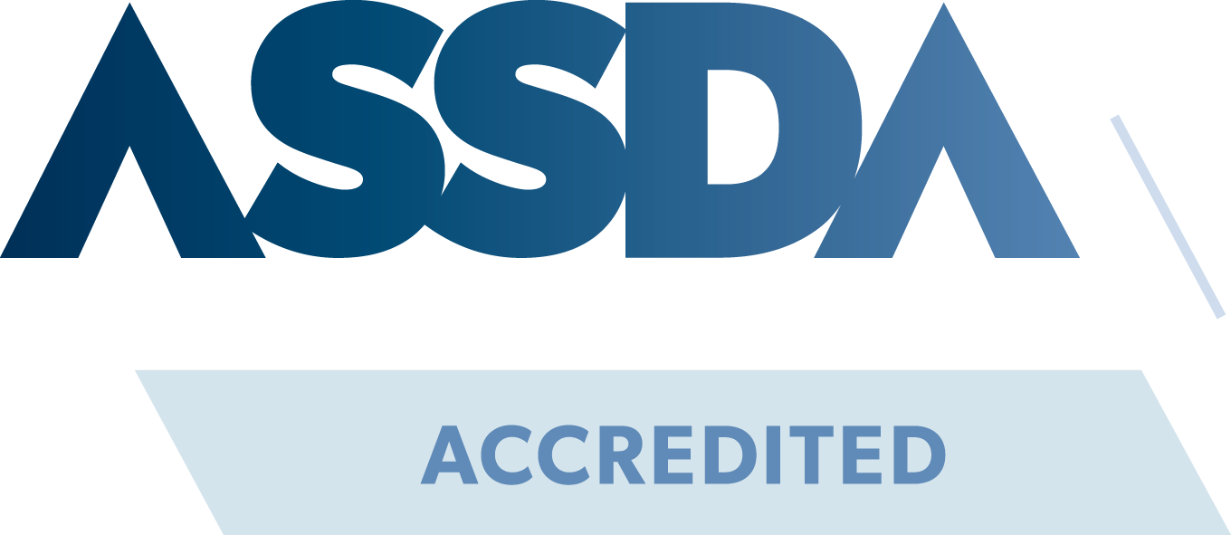

Thank you for making the decision to become ASSDA Accredited. Since its inception in 2004, the program has been a critical vehicle for the industry to demonstrate competence in the handling and manufacturing of stainless steel products in Australia.

By committing to become an ASSDA Accredited Fabricator, you are sending the industry, particularly specifiers and end-users, a clear message of your dedication to industry best practice, quality and service.

Introduction
The application for ASSDA Accreditation has been designed not only as a method for ASSDA to gather the required information, but for the Applicant to identify strengths and weaknesses in their own organisation and, provide a clear indication where improvement can be achieved. The application process examines:

- Workshop capabilities
- Practices to avoid workshop contamination
- Quality control and quality assurance
- Safety management
- Training systems
- A comprehensive stainless steel specific knowledge statement

By completing this application, organisations can identify areas for improvement, in which ASSDA can provide assistance.

The information provided in this application will be used by ASSDA as the basis for admission to the program. The information must be accurate at the time of application, and a director of the company making the application must submit the application. The responsible director must initial each page.

ASSDA Accreditation Fee Structure

ACCREDITATION FEE

New: $1,500.00 + GST (ASSDA Members)
$2,000.00 + GST (ASSDA non-members)

A 25% deposit (non-refundable) of the Accreditation fee is required upon return of Part 1 to progress with the application. The remaining balance will be due when your ASSDA Accreditation has been approved.

Annual renewal: $990.00 + GST (ASSDA Members)
$2,000.00 + GST (ASSDA non-members)

The Accreditation fee covers a one-year period, from the date you are accepted into the program.

An annual renewal fee of $990 (ASSDA Member) or $2000 (non-member) is due on the anniversary of your Accreditation (ASSDA will send out a reminder with due invoice) to ensure ongoing currency of Accreditation.

All fees are exclusive of GST.

Completing this Application Form

This form can be completed in two ways, both acceptable;

- Print the entire file, and populate the fields manually using pen on paper.

- Populate the fields electronically and print before signing.

Finally, scan the entire completed document and return to ASSDA.

If Option 2 is chosen, please review the below notes to make this as easy and fast as possible for you.

- Check boxes - Double click on the checkbox to open an options menu. In this menu, under default value heading, toggle the “checked” option, then enter OK.

- Text fields - ____ Click on the field above the line and start typing.

- Entry field - Click in the box and start typing.

PART A – BUSINESS DETAILS

A1 Business Type
Incorporated Entity Partnership
Sole Trader Trust
Other (please specify):

A2 Registered Name of Business

A3 Date of First Registration

A4 Australian Business Number (ABN)

A5 Trading Name (If different to Registered Name)

A6 Head Office Postal Address Head Office Street Address

Contact Details
Phone: ( )
Email: Website:

A7 States/Territories in which the Company trades
New South Wales Victoria
Queensland Western Australia
South Australia Northern Territory
Australian Capital Territory Tasmania
Other overseas (specify):

A8 Addresses of any branches (Please attach additional sheet(s) if more than one branch)
Contact: Email:
Postal Address: Street Address:

Phone: ( )
A9 Company Directors
Please provide details of all the directors of the business wishing to join the Stainless Steel Specialists Register, as supplied to ASIC and credit reference bureaux. Please note this information is for the use of ASSDA and the ASSDA Board only and will not be divulged to any other party.

1. Name:
Date appointed:
Date of Birth:
Address:
Resident overseas?

2. Name:
Date appointed:
Date of Birth:
Address:
Resident overseas?

3. Name:
Date appointed:
Date of Birth:
Address:
Resident overseas?

4. Name:
Date appointed:
Date of Birth:
Address:
Resident overseas?

5. Name:
Date appointed:
Date of Birth:
Address:
Resident overseas?

6. Name:
Date appointed:
Date of Birth:
Address:
Resident overseas?
A10 Insurance Details

Please forward Certificate of Currency to ASSDA for all policies held.

Work Cover | Provider:  Policy No:  Current to (date):
Public Liability | Provider:  Policy No:  Current to (date):  Amount of cover: $
Any other applicable insurance (including product liability insurance) | Provider:  Type:  Policy No:  Current to (date):
Provider:
Type:
Policy No:
Current to (date):

Provider:
Type:
Policy No:
Current to (date):

Provider:
Type:
Policy No:
Current to (date):

PART B – SCOPE OF REGISTRATION

B1 Business Function

Fabrication services

Installation services

Speciality:
(Do you specialise in a particular area or type of fabrication, e.g. machining, 3D printing?)

B2 Industry Category

In which industries do you undertake at least 30% of your total work?

Architectural

Food, Dairy and Beverage

Heavy Industrial (Generally >3mm typical section thickness)

Light Commercial (Generally <3mm typical section thickness)

PART C – BUSINESS CAPABILITY

C7 Employee / Contractor Function Analysis
List number of employees, contractors/sub-contractors engaged in specific activities/roles. Contractors are limited to the number of people under your direct control. Where a person does more than one function, include them in more than one category – we are looking for the total effort available.

Job Function | Personnel for whom this is their primary function | Total Number of People Performing the Role
Job Function | Personnel for whom this is their primary function | Employees | Contractors
Administration
Sales and/or Estimating
Engineering Design
Drafting
Project Supervision
Manufacture Management, Purchasing, Planning and Supervision
Tradesmen/Trades Assistants
Installation Personnel
Apprentices
Non Trade Qualified Personnel

(Welding, polishing, assembly, machine operation etc)
TOTAL
(This equals the total number of people in your organisation)

Code of Ethics and Practice

Accredited businesses of the ASSDA’s Stainless Steels Specialists Register must:

- Aspire to the highest level of business ethics, as generally expected by the business community.
- Aspire to the highest level of industry competence through continued education, and by sharing ideas and experiences with other SSSR accredited businesses.
- Be honest and thorough in all business dealings, including dealings with clients, client customers, specifiers and other members of the stainless steel industry.
- Undertake professional practice in a responsible, careful and diligent manner at all times, and only in their relevant areas of expertise.
- Not disclose any confidential information acquired in the course of professional practice unless required to do so by law.
- Respect the privileges, rights and reputation of other accredited businesses of the Stainless Steel Specialists Register.
- Not engage in any activity constituting, or leading to, a conflict of interest.
- Treat all persons fairly and equally, regardless of race, religion, gender, disability, age or ethnicity.
- Only make public statements, express opinions or give evidence based on adequate knowledge. Accredited businesses shall adhere to truth in advertising standards.
- Strive to promote the ASSDA SSSR and its goals, as well as the stainless steel industry as a whole, through educational venues, public relations opportunities, and advertising media.
- Communicate non-confidential information relating to other accredited businesses in violation of this code of ethics to ASSDA.
- Maintain appropriate levels of insurance cover throughout the full period of registration applicable in the particular State or Territory of practice.
- Enable a client or subcontractor to reach an informed opinion regarding its overall capacity in order to assess risk.
- Be able to demonstrate an ability to manage and deliver projects within the specified time.
- Establish and maintain effective systems to manage the risks to the health and safety of all personnel, arising from the nature of the work performed.
- Abide by and endeavour to secure the widest possible acceptance of this code of ethics and practice.

PART D – DIRECTOR DECLARATION

Please re-read your application carefully before signing this declaration. Return the entire application with the signed declaration.

I certify that the information provided in this application is true and correct, to the best of my knowledge.

I have read and accept the Code of Ethics and Practice, and will endeavour to ensure that it will be followed at all times.

Name:

Position:

Signature: Date:

